Shuttle Info

https://groometransportation.com/denver-airport/

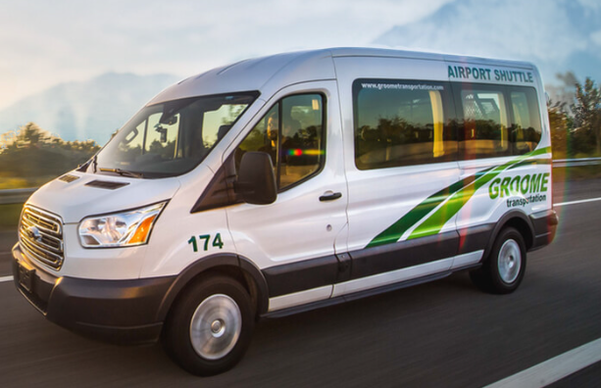GROUP CHARTERS / CORPORATE ACCOUNTS
Groome Transportation operates across Alabama, Arizona, California, Colorado, Georgia, Minnesota, New Mexico, Oregon, Tennessee, and Wisconsin. Our offices can provide you with easy, reliable, and safe transportation at a price that won’t break your budget. Requests are subject to availability and advance reservations are highly encouraged.
GROUP CHARTERS:
Are you planning a private event and need transportation for your guests? Groome Transportation is here to help with over 80 years’ experience organizing charter service for a variety of events. Whenever a crowd gathers, rides need to be planned, too. Anytime you get involved in planning for an event, call your local Groome office for ideas or a quote.
Some possibilities are: sporting events, religious events, grand opening events, association events, conferences, receptions and musical venues. We can provide you with easy, reliable, and safe transportation. Requests are subject to availability and advance reservations are required. Our knowledgeable transportation coordinators will help you determine what kind of equipment is best suited for your group. Call your local Groome office to make a reservation!
To expedite the quote process, our travel coordinators will need the following information:
- Date of travel
- Group size
- Pickup location and time
- Destination
- Drop-off location and time
- Any other pertinent itinerary information

